PAF2018 in Paris Terms and Conditions

10.17. Wed ~ 20. Sat. 2018

Bastille Design Center, Paris

Application Submission

The application for participation in the ‘PAF2018 in Paris’ is open.
You will find the terms and conditions for the participation on our website http://paf2018.com, and submit your application form (to be downloaded from the website) before the deadline, fixed at 6pm on 31 August 2018.

E-mail : paf2018paris@gmail.com / Name of file: paf2018, Name of artist

PAF2018 Outline

Site | Bastille Design Center, Paris (74 Boulevard Richard Lenoir, 75011 Paris, France)
Period | 2018.10.17. (Wed.) ~ 10.20 (Sat.) (during 4 days)
Opening hours | 10:00 ~ 20:00, but till 17 at the last day, 20th October (Sat.)
Opening ceremony | 2018.10.17.(wed.) 15:00
Exhibition genres | Korean painting, calligraphy, Western painting, sculpture, installation, photography, media art, drawing, engraving, crafts, etc.

Schedule

Submission of participation form | 25th June (Mon.) ~ 1st September (Sat.) 18:00
Submission of information for art catalogue | 10th September (Mon.) 18:00
Take in and installation | 16th October (Wed.) 10:00~20:00
Demolition and take out | 20th October (Sat.) 17:00~20:00

PAF2018 in Paris Terms and Conditions

10.17. Wed ~ 20. Sat. 2018

Bastille Design Center, Paris

Floor Plan of Exhibition Center

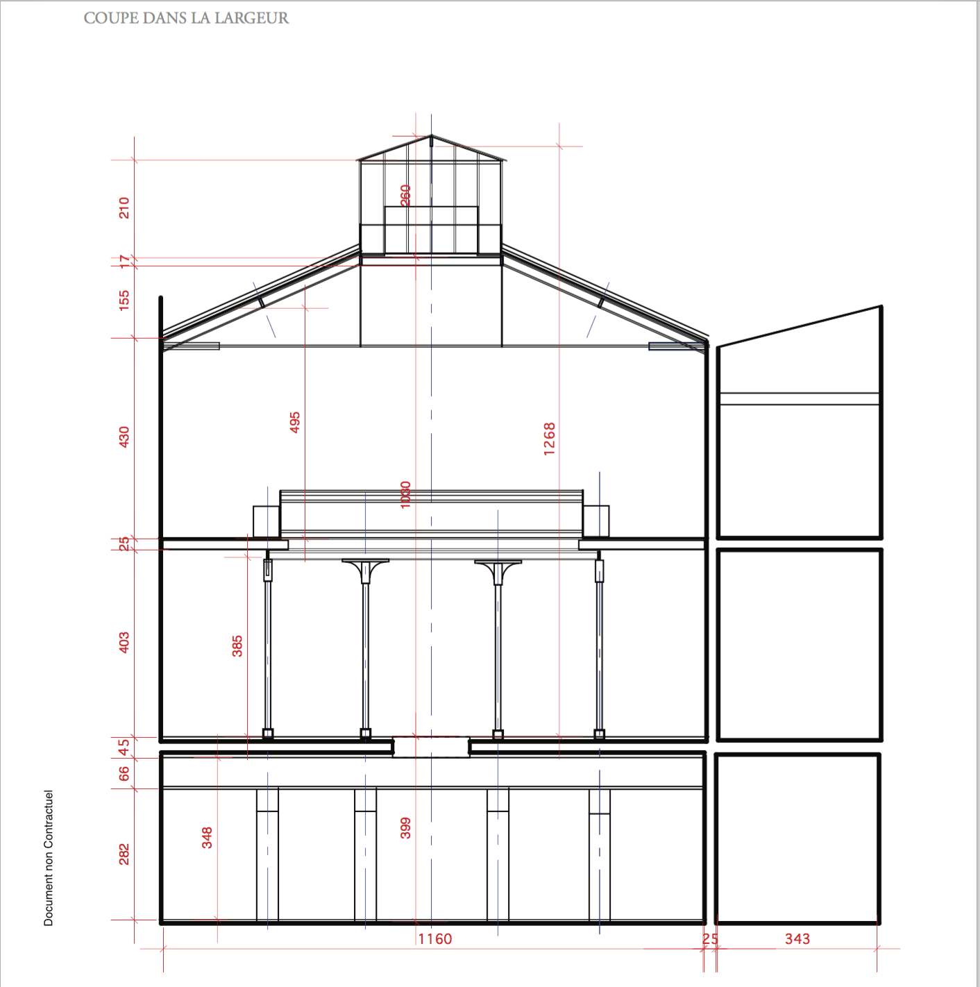 | 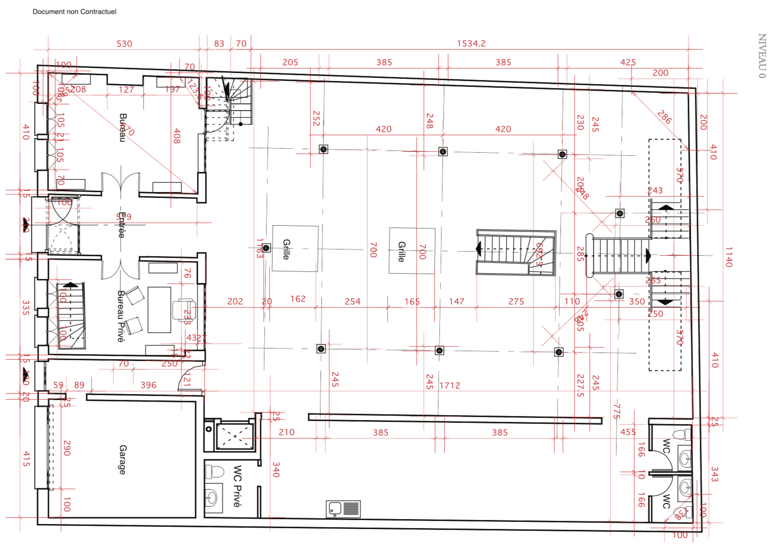
ALL | F1
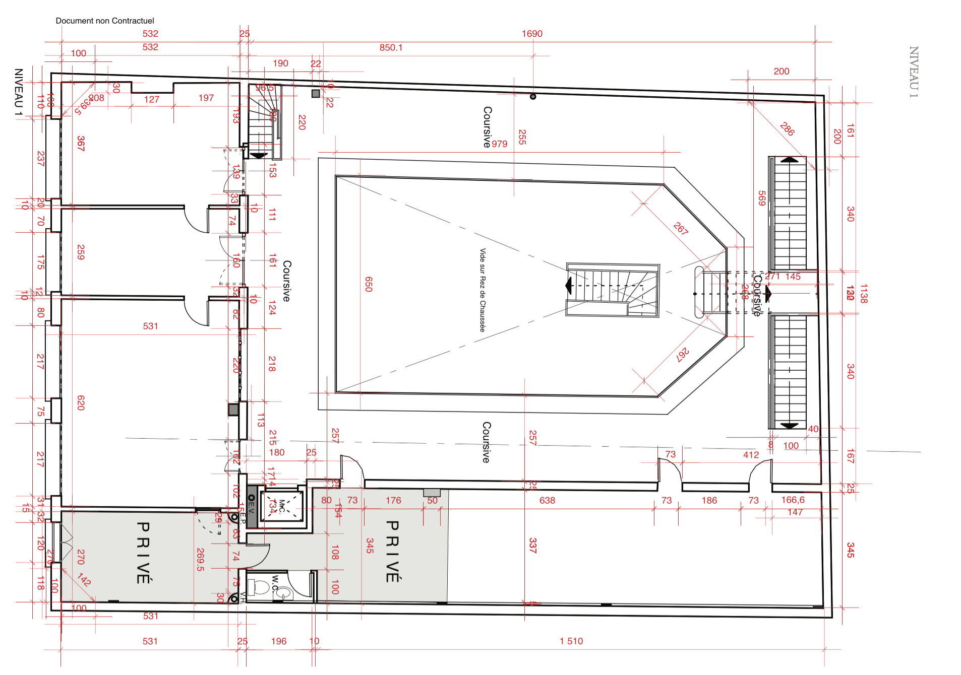 | 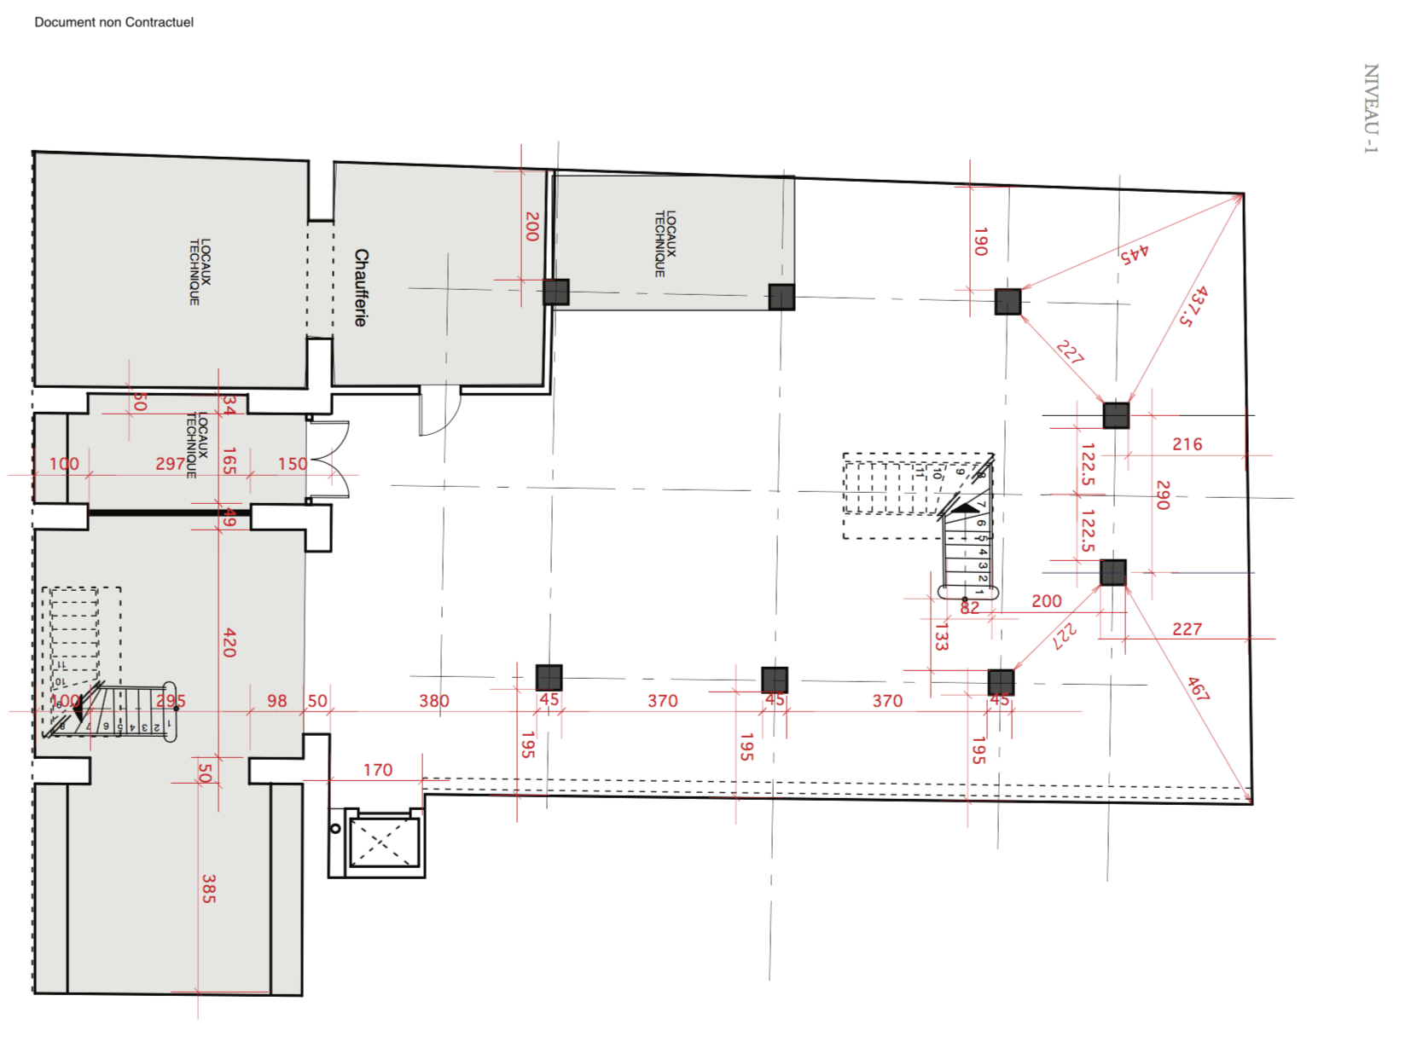
F2 | B1

Deposit Account : 651401-04-459009 KB, HA Hou-sun(PAF)
※ The name of depositor should be the name of participating artist. If the two persons are not same, it is necessary to announce to the executive office.

Required Submissions

- Application form - Copyright Agreement
- Written Oath - Personal information provision and Use Agreement

PAF2018 in Paris Terms and Conditions

10.17. Wed ~ 20. Sat. 2018

Bastille Design Center, Paris

Terms and Conditions

1. ADMISSION TO EXHIBITION
- The Committee reserves the right to cancel any application that is accepted on the basis of false information or if the exhibitor fails to comply with the Conditions of Participation.
- The Committee has the right to require complete details of a proposed exhibit, and reserves the right to prohibit the exhibition of any object that the committee deems inappropriate for the festival.
- The exhibitor guarantees that all information in his/her application is accurate and that all works submitted for exhibition are authentic.
- In case of the removal of such objects infringing Terms and Conditions, it will be at the expense of the exhibitor.

2. USE OF BOOTHS
- The exhibitors are not allowed to display advertisement of any type within and around the booth, other than the art works that appear on the application.
- The use of spaces that go beyond (horizontally and vertically) the boundary of provided booth is only available with the Committee’s prior approval.
- The displaying of artworks should be maintained until the end of the exhibition.
- PAF2018 office does not provide any caption or description pieces for artworks except for a nameplate of booth.

3. INFORMATION ON DISPLAYED ART WORK
- Information on displayed works, including captions and the list of artworks, must be provided for visitors correctly. (caption, works list, price, etc)
- For future evaluations and reports, The Committee will require sales reports. Upon requests, the exhibitors must provide such information. If not inform to the Committee or inform false information, a penalty will be applied.

4. CATALOGUE
- All exhibitors must submit au minimum one high-quality image (600dpi) by e-mail: paf2018paris@gmail.com before Sep 10(Mon), 2018.
- The exhibitor cannot design or edit independently the catalog lay out, that right is to be hold by The Committee.
- The Committee reserves the right to use images of works to be submitted for catalog.
- Each exhibitor will receive one catalog, and if necessary he can buy catalogs at the price determined by the Committee.

5. STORAGE
- The exhibitors are not provided storage for works in the show areas but for wrapping materials at designated place.
- The Committee is not responsible for any loss or damages of the wrapping materials.

6. INSURANCE AND EXEMPTION FROM LIABILITY
- All participants are required to insure against risks such as damage of artworks that could result from not also fire, theft, robbery, water leaks but also the movement of facilities or goods in the exhibition hall.
- In any case, the participant is responsible for the loss of the participant's work.
- The Commission is only responsible for the damages of visitors who may occur in the exhibition hall. The Committee shall have no responsibility for any direct or indirect damages or losses that could be occurred to the participating artists during the Exhibition.

7. SECURITY
- The security service will continue from the first day of installation to the end of the release.
- To ensure security, no artwork can be taken out of the exhibition hall without a proof of delivery from the beginning of the installation to the end of the exhibition.
- The Committee is not responsible for any loss of the exhibiting works.

8. ELECTRICAL SERVICES
- Commission shall not be responsible for any damages or losses caused by the power failure.
- Self-contained power connections cannot be used, and fire, safety, and security regulations must be observed.

9. FEES AND SPONSORSHIP
- Deposit Account : 651401-04-459009 KB, HA Hou-sun(PAF)

10. OTHER CONDITIONS
- The committee may postpone, shorten, or extend the exhibition schedule in cases that are unavoidable, such as natural disasters.
- The executive committee has the right to expel participants from the exhibition for violating regulations stipulated in the terms of participation.
- French law shall apply to this Agreement and any legal matters arising out of participation in the exhibition, and the consequential legal dispute shall be under the jurisdiction of the Paris Court.
- Lamps can be rented at Bastille Design Center for €5/1 day each.

